|  |
| --- |
| Project Report  Humming Bee Garden Water Sprinkler System  C:\Users\Steph\Pictures\Microsoft Clip Organizer\j0387802.jpg |
| By Vinay Sagar Gonabavi Shivam Verma |

Table Of Contents

1. UI Flow…………………………………………………………………………03
2. UI Screen………………………………………………………………………04

2.1 Welcome Page…………………………………………………………..04

2.2 Information Page………………………………………………………05

2.3 Home Page……………………………………………………………….06

2.4 Configuration by Group……………………………………………..07

2.5 Garden Layout………………………………………………………….08

2.6 View Schedule………………………………………………………….09

2.7 Water Usage…………………………………………………………….10

2.8 View Status………………………………………………………………11

2.9 Temperature Settings………………………………………………..12

2.10 Activate / Deactivate Group……………………………………..13

1. UI Flow

1 Welcome Page

Click_Submit

2 Information Page

4.7

Act / Deact Group

4.6 Temp Setting

4.5

View Status

4.4 Water Usage

4.3

View Schedule

4.2 Garden Layout

4.1 Config by Group

3. Home Page

2. UI Screen

2.1 Welcome Page

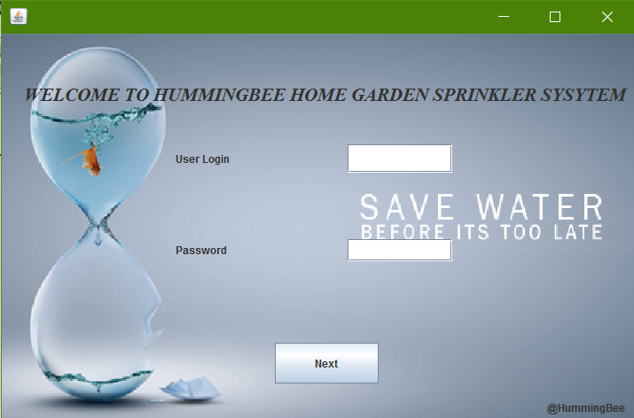

2.2 Information Page

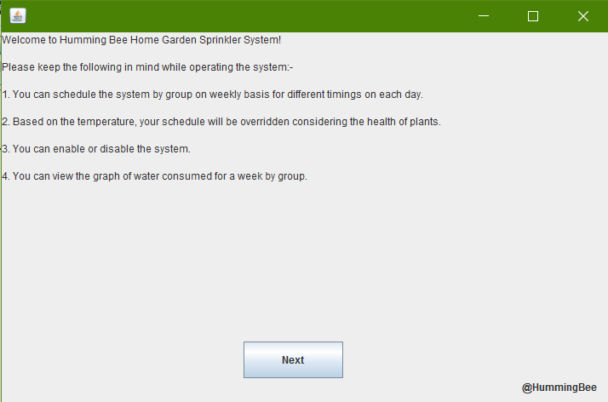

2.3 Home Page

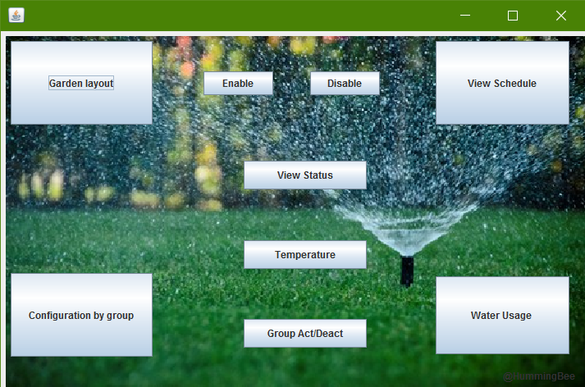

2.4 Configuration by Group

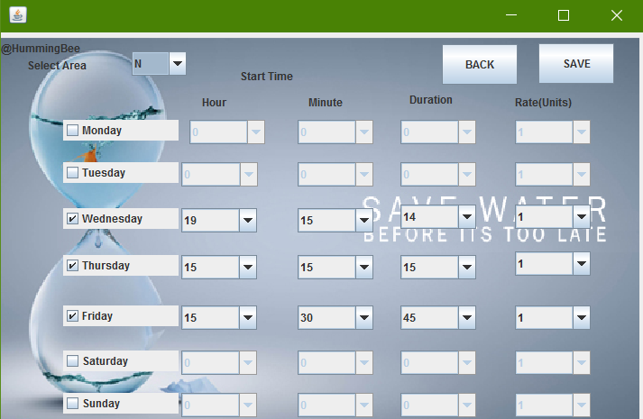

2.5 Garden Layout

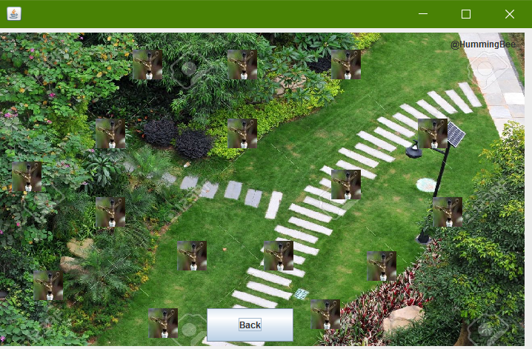

2.6 View Schedule

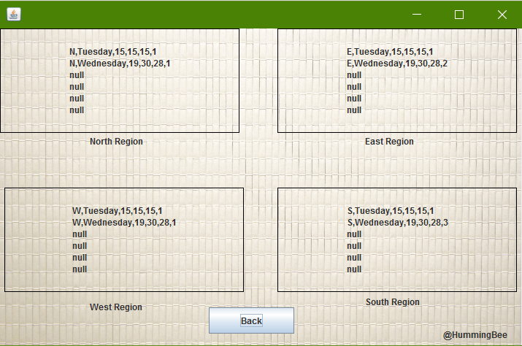

2.7 Water Usage

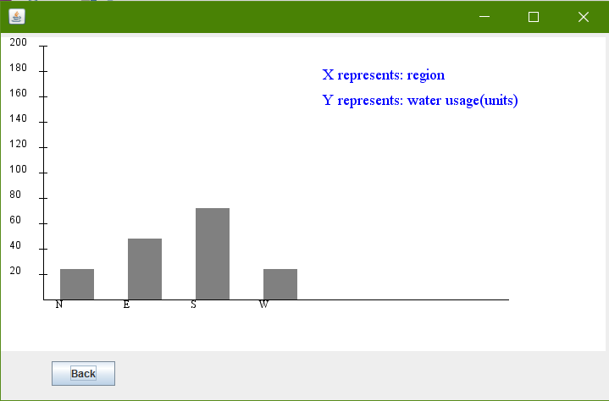

2.8 View Status

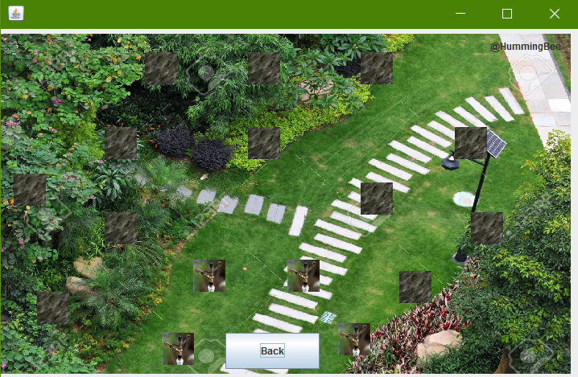

2.9 Temperature Settings

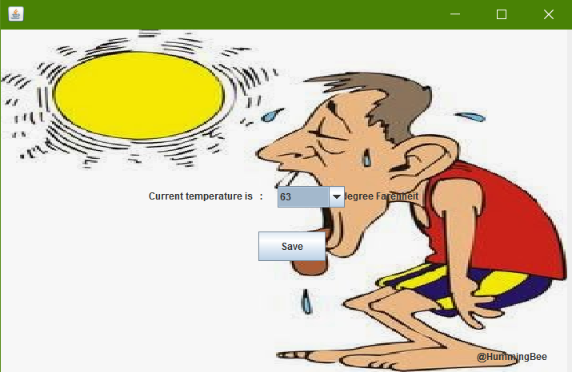

2.10 Activate / Deactivate Group

